**Optimization Techniques**

**LECTURE NOTES**

**II- B.TECH & II- SEM**

**UNIT - II**

**Prepared by:**

**Dr. M. Vijaya Lakshmi**

**Associate Professor**

**Department of Basic Science**

**Vishnu Institute of Technology, Bhimavaram**



**VISHNU INSTITUTE OF TECHNOLOGY**

**(AUTONOMOUS)**

**VISHNUPUR, BHIMAVARAM – 534 202**

**Department of Basic Science**

**Class : II B Tech II Semester Subject :OT (R-23)**

**Branch : IT – C & IT - D**

**UNIT –II**

|  |  |
| --- | --- |
|  | TITLE OF CONTENT |
| 2.1. | Introduction-LPP |
| 2.2. | Standard form of a linear programming problem |
| 2.3. | Geometry of linear programming - problems |
| 2.4. | Solution of a system of linear simultaneous equations |
| 2.5 | Pivotal reduction of a general system of equations |
| 2.6. | Motivation to the simplex method |
| 2.7 | Simplex algorithm |

**2.1 INTRODUCTION-LPP**

Linear programming is an optimization method applicable for the solution of problems in which the objective function and the constraints appear as linear functions of the decision variables.

The constraint equations in a linear programming problem may be in the form of equalities or inequalities.

The linear programming type of optimization problem was first recognized in the 1930s by economists while developing methods for the optimal allocation of resources.

During World War II the U.S. Air Force sought more effective procedures of allocating resources and turned to linear programming. George B. Dantzig, who was a member of the Air Force group, formulated the general linear programming problem and devised the simplex method of solution in 1947.

This has become a significant step in bringing linear programming into wider use. Afterward, much progress was made in the theoretical development and in the practical applications of linear programming.

Among all the works, the theoretical contributions made by Kuhn and Tucker had a major impact in the development of the duality theory in LP. The works of Charnes and Cooper were responsible for industrial applications of LP. Linear programming is considered a revolutionary development that permits us to make optimal decisions in complex situations.

* + 1. **APPLICATIONS OF LINEAR PROGRAMMING**
* An oil refinery has a choice of buying crude oil from several different sources with differing compositions and at differing prices. It can manufacture different products, such as aviation fuel, diesel fuel, and gasoline, in varying quantities. The constraints may be due to the restrictions on the quantity of the crude oil available from a particular source, the capacity of the refinery to produce a particular product, and so on. A mix of the purchased crude oil and the manufactured products is sought that gives the maximum profit. The optimal production plan in a manufacturing firm can also be decided using linear programming.
* The sales of a firm fluctuate, the company can have various options. It can build up an inventory of the manufactured products to carry it through the period of peak sales, but this involves an inventory holding cost. It can also pay overtime rates to achieve higher production during periods of higher demand. Finally, the firm need not meet the extra sales demand during the peak sales period, thus losing a potential profit. Linear programming can take into account the various cost and loss factors and arrive at the most profitable production plan.
* In the food-processing industry, linear programming has been used to determine the optimal shipping plan for the distribution of a particular product from different manufacturing plants to various warehouses. In the iron and steel industry, linear programming is used to decide the types of products to be made in their rolling mills to maximize the profit.
* Metalworking industries use linear programming for shop loading and for determining the choice between producing and buying a part.
* Paper mills use it to decrease the amount of trim losses.
* The optimal routing of messages in a communication network and the routing of aircraft and ships can also be decided using linear programming.
* Linear programming has also been applied to formulate and solve several types of engineering design problems

**2.1.3 Mathematical formulation of LPP**

There are four basic components of an LPP:

• Decision variables - The quantities that need to be determined in order to solve the LPP are called decision variables.

• Objective function - The linear function of the decision variables, which is to be max- imized or minimized, is called the objective function.

• Constraints - A constraint is something that plays the part of a physical, social or financial restriction such as labor, machine, raw material, space, money, etc. These limits are the degrees to which an objective can be achieved.

• Sign restriction - If a decision variable xi can only assume nonnegative values, then we use the sign restriction xi ≥ 0. If a variable xi can assume positive, negative or zero values, then we say that xi is unrestricted in sign.

A linear programming problem (LPP) is an optimization problem in which

(i) The linear objective function is to be maximized (or minimized);

(ii) The values of the decision variables must satisfy a set of constraints where each constraint must be a linear equation or linear inequality;

(iii) A sign restriction must be associated with each decision variable.

Two of the most basic concepts associated with LP are feasible region and optimal solution.

• Feasible region - The feasible region for an LPP is the set of all points that satisfy all the constraints and sign restrictions.

• Optimal solution - For a maximization problem, an optimal solution is a point in the feasible region with the largest value of the objective function. Similarly, for a minimization problem, an optimal solution is a point in the feasible region with the smallest value of the objective function.

**2.1.2 General Linear Programming Problem**

A general linear programming problem can be mathematically represented as follows:

Maximize (or Minimize) Z = c1x1 + c2x2 + ... + cnxn

subject to,

a11x1 + a12x2 + a13x3 + ... + a1jxj + ... + a1nxn (≤, =, ≥) b1

a21x1 + a22x2 + a23x3 + ... + a2jxj + ... + a2nxn (≤, =, ≥) b2

.............................................................................................

ai1x1 + ai2x2 + ai3x3 + ... + aijxj + ... + ainxn (≤, =, ≥) bi

.............................................................................................

am1x1 + am2x2 + am3x3 + ... + amjxj + ... + amnxn (≤, =, ≥) bm

and x1, x2, ..., xn ≥ 0

The above can be written in compact form as

Maximize (or Minimize) Z = ∑cjxj (2.1)

subject to,

∑aijxj(≤, =, ≥) bi; i = 1, 2, ..., m (2.2)

Non negativity

xj ≥ 0; j = 1, 2, ..., n. (2.3)

The problem is to find the values of xj’s that optimize (maximize or minimize) the objective function (2.1). The values of xj’s must satisfy the constraints (2.2) and non- negativity restrictions (2.3).

Here, the coeﬃcients cj’s are referred to as cost coeﬃcients and aij’s as technological coeﬃcients; aij represents the amount of the ithresource consumed per unit variable xj and bi, the total availability of the ith resource.

**2.2 STANDARD FORM OF A LINEAR PROGRAMMING PROBLEM**

The general linear programming problem can be stated in the following standard

forms:

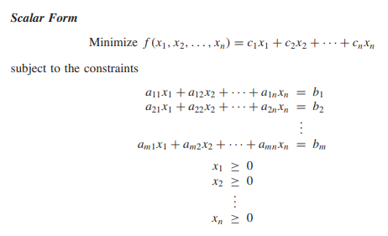

Where cj ,bj , and aij (i = 1, 2, . . . , m; j = 1, 2, . . . , n) are known constants, and xj

are the decision variables.

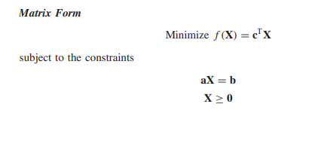

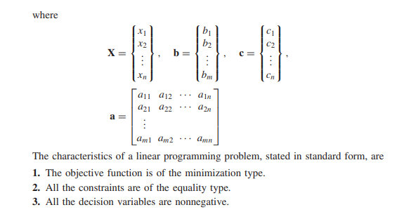

Note:

Thus if xjis unrestricted in sign, it can be written as xj = x′j − x′′j, where

x′j ≥ 0 and x′′j ≥ 0

* 1. **Geometrical Representation**

**Problems**

To solve an LPP, the graphical method is used when there are only two decision vari- ables.If the problem has three or more variables then we use the simplex methodwhich will be discussed in the next section.

* SolvethefollowingLPPbygraphicalmethod:

Minimize*Z*=20*x*1+10*x*2 subject to

*x*1+2*x*2≤40

3*x*1+*x*2≥30

4*x*1+3*x*2≥60

*x*1*,x*2≥0*.*

Solution:Plotthegraphsofallconstraintsbytreatingaslinearequation.Thenuse the inequality constraints to mark the feasible region as shown by the shaded area in Fig. 2.1. This region is bounded below by the extreme points A(15,0), B(40,0), C(4,18) and D(6,12).The minimum value of the objective function occurs at the point D(6,12). Hence, the optimal solution to the given LPP is *x*1=6*,x*2=12and*Zmin*=240.

*x*2

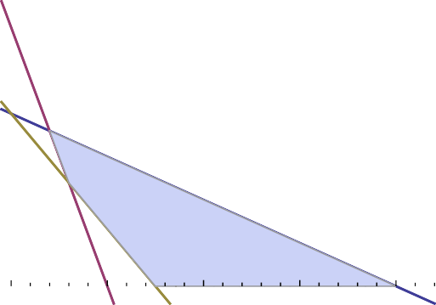

30

25

20

C(4,18)

15

D(6,12)

10

5

A(15,0)

O(0,0) 10

20

30

B(40,0)

40

Extreme Objectivefunction point *Z* = 20*x*1 + 10*x*2 A (15,0) 300

B(40,0) 800

C(4,18) 260

D(6,12) 240

*x*1

flg.2.1:Unique optimalsolution

* **SolvethefollowingLPPbygraphicalmethod:**

Maximize*Z* =4*x*1+3*x*2 subject to

*x*1+2*x*2≤6

2*x*1+*x*2≤8

*x*1≥7

*x*1*,x*2≥0*.*

Solution:TheconstraintsareplottedonthegraphasshowninFig.2.2.Asthereis nofeasibleregionofsolutionspace,theproblemhasnofeasiblesolution.

x2

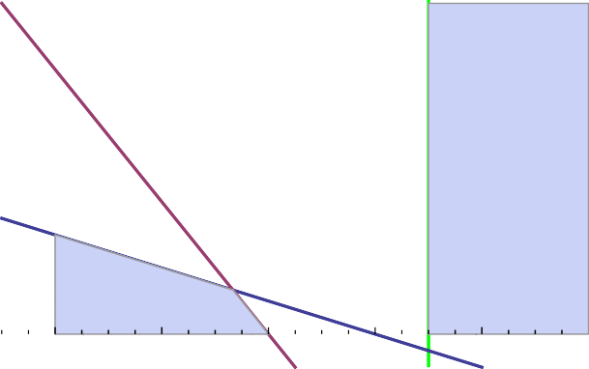

8

6

4

*x*1=7

*x*1+2*x*2=6

2*x*1+*x*2=8

2

O(0,0) 2

4

6

8

*x*1

flig.2.2:Nofeasiblesolution

**Problem:Show by graphical method that the following LPP has unbounded solution.**

Maximize*Z* =3*x*1+5*x*2 subject to

*x*1+2*x*2≥10

*x*1≥5

*x*2≤10

*x*1*,x*2≥0*.*

Solution:From the graph as shown in Fig.2.3,it is clear that the feasible region isopen-ended.Therefore,the value of *Z*can be made infinitely large without violatinganyoftheconstraints.HencethereexistsanunboundedsolutionoftheLPP.

*X*2

*x*1

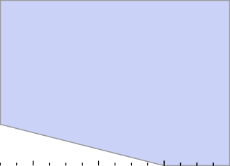

10

*x*2=10

*x*1=5

5

*x*1+2*x*2=10

O(0,0)2

4

6

8

10

flig.2.3:Unbounded solution

Note:Unboundedfeasibleregiondoesnotnecessarilyimplythatnofiniteoptimalso- lutionofLPproblemexists.ConsiderthefollowingLPPwhichhasanoptimalfeasible

* **Solution in spite of unbounded feasible region:**

Maximize*Z*=2*x*1−*x*2

subjectto

*x*1−*x*2≤1

*x*1≤3

*x*1*,x*2≥0

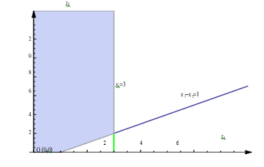

Infeasible Solution

**Problem:SolvethefollowingLPproblembygraphicalmethod:**

Maximize*Z* =3*x*1+2*x*2 subject to

6*x*1+4*x*2≤24

*x*2≥2*,x*1≤3*, x*1*,x*2≥0*.*

Solution:Theconstraintsareplottedonagraphbytreatingasequationsandthen theirinequalitysignsareusedtoidentifyfeasibleregionasshowninFig.2.5.

TheextremepointsoftheregionareA(0,2),B(0,6),C(2,3)andD(2,2).Theslope oftheobjectivefunctionandthefirstconstraintequation6*x*1 + 4*x*2=24coincideat lineBC.Also,BCistheboundarylineofthefeasibleregion.

*x*2

Table1.1



6B(0,6)

4

C(2,3)

2

A(0,2)

D(2,2)

O(0,0) 2

4

6

*x*1

flig.2.5: Aninfinitenumberofoptimal solutions

Corners ObjectiveFunction (x, y) *Z* = 3*x*1 + 2*x*2

A(0,2) 4

B(0,6) 12

C(2,3) 12

D(2,2) 10

The optimal solution of LP problem can be obtained at any point lies on the line segmentBC. It is observed from Table 1.1 that the optimal value (*Z* = 12) is the same at two differentextremepointsBandC.Therefore,severalcombinationsofanytwopoints on the line segment BC give the same value of the objective function, which are also optimal solutions of the LP problem.Hence, there exists an infinite number of optimal solutions of the given LP problem.

**Definitions and Theorems**

• **Closed half plane -** A linear inequality in two variables is known as a half plane. The corresponding equality or the line is known as the boundary of the half plane. The half plane along with its boundary is called a closed half plane.

• **Convex set -** A set is convex if and only if, for any two points on the set, the line seg- ment joining those two points lies entirely in the set. Mathematically, A set S is said to be convex if for all x, y ∈ S, λx + (1 − λ)y ∈ S, for all λ ∈ [0, 1].

For example, the set S = {(x, y) : 3x + 2y ≤ 12} is convex because for two points (x1, y1) and (x2, y2)∈ S, it is easy to see that λ(x1, y1) + (1 − λ)(x2, y2) ∈ S for all λ ∈ [0, 1].

On the other hand, the set S={(x, y) : x2 + y2 ≥ 16} is not convex. Note that the two points (4,0) and (0,4) ∈ S but λ(4,0) + (1-λ)(0,4) < S for λ = 1/2.

• **Convex polygon -** A convex polygon is a convex set formed by the intersection of a finite number of closed half planes.

• **Extreme points -** The extreme points of a convex polygon are the points of intersection of the lines bounding the feasible region.

• **Feasible solution (FS)** - Any non-negative solution which satisfies all the constraints is known as a feasible solution of the problem.

• **Basic solution (BS) -** For a set of m simultaneous equations in n variables (n > m) in an LP problem, a solution obtained by setting (n − m) variables equal to zero and solving for remaining m equations with m variables is called a basic solution. These m variables are called basic variables and (n − m) variables are called non-basic variables.

• **Basic feasible solution (BFS)-** A basic solution to an LP problem is called basic feasible solution (BFS) if it satisfies all the non-negativity restrictions. A BFS is called degener- ate if the value of at least one basic variable is zero, and non-degenerate if the values of all basic variables are non-zero and positive.

• **Optimal basic feasible solution** - A basic feasible solution is called optimal, if it opti- mizes (maximizes or minimizes) the objective function.

The objective function of an LPP has its optimal value at an extreme point of the convex polygon generated by the set of feasible solutions of the LPP.

• **Unbounded solution** - An LPP is said to have unbounded solution if its solution can be made infinitely large without violating any of the constraints.

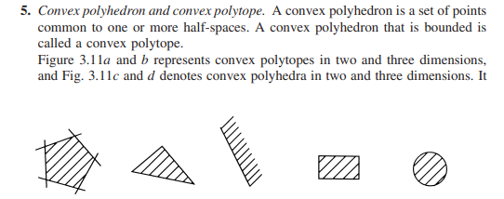

**Convex sets**

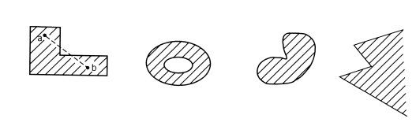

**Non Convex sets**

**Theorem 1. The intersection of any number of convex sets is also convex**

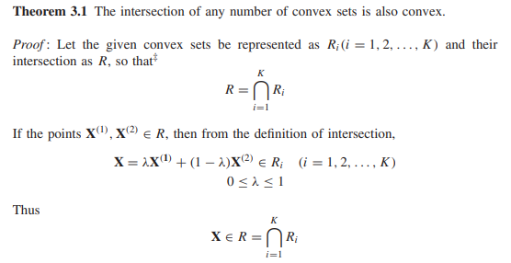

Hence Proved.

**Theorem 2. The feasible region of linear programming problem is convex**

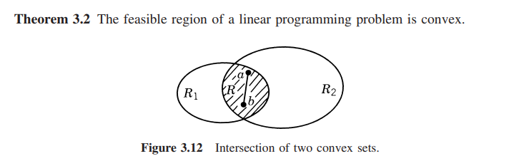

Intersection of two convex sets

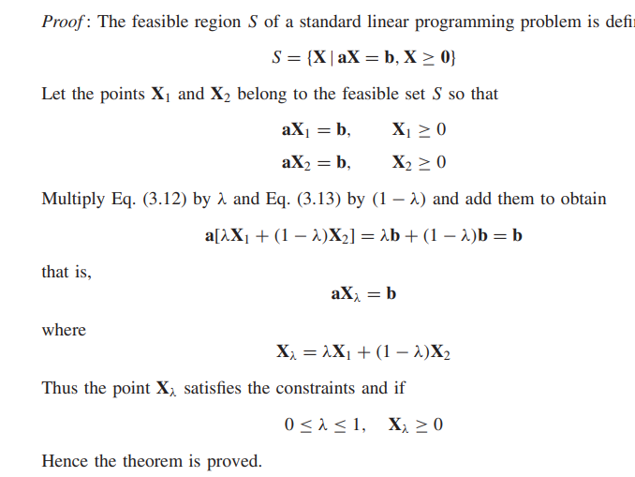

…(2)

…(1)

Multiply Eq. (1) by λ and Eq. (2) by (1 − λ) and add them to obtain



3. Every basic feasible solution is an extreme point of the convex set of feasible solutions.